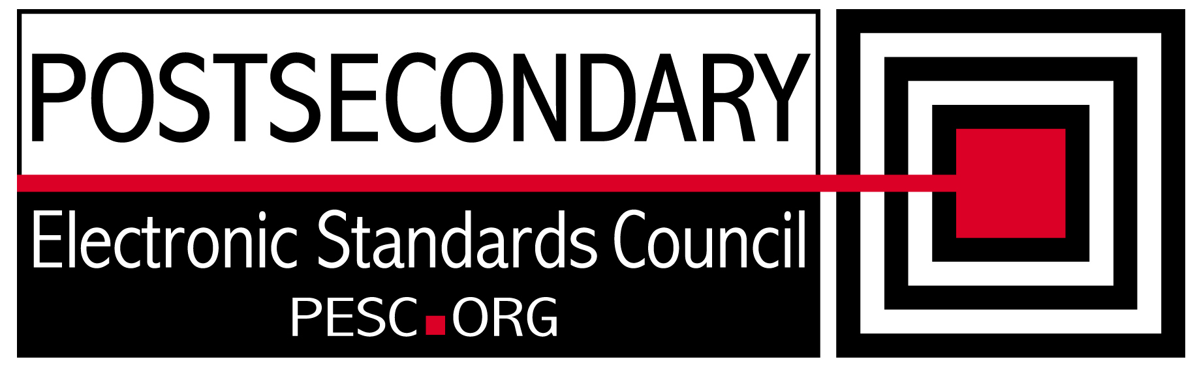

Standards Forum for Education
Status Update Form

Workgroup/Board Group Name | Technical Advisory Board
General Summary of Status | Reviewed PESC schemas to determine the changes needed for NIEM
Status Flag (Red/Yellow/Green) | Green
Report Data | 4/16/12
Projected Completion Date | Standing PESC Board

Item | Responsible Resource | Status  (Report update status of Deliverable/Objective  since last report)
Planned Deliverables/Objectives
(Provide at least 3)
Component Architecture: Single file schema | Morris/TAB | NIEM provides a subset schema concept that can be used to simplify PESC schemas. This will be merged with NIEM project on the next report.
NIEM Evaluation | TAB/David Webber | Reviewed core-main and sector libraries to determine what changes were required for providing an education domain in NIEM
XML R&R | Morris/Sue Lou (FSA) | Waiting for definitions and transform from CAM tool
Guideline for XML Architecture and Data Modeling revision | TAB | On hold until NIEM approach is settled.
Accomplishments/
Completions
NIEM Evaluation | David Webber | Created data dictionary from core-main using CAM tool. Created automation to merge xs:groups into their parent’s structures.
Issues/Obstacles
Meetings/Calls Since Last Update | 4

Note: Chairs and/or leaders of workgroups, boards and committees under The Standards Forum for Education are required to provide updates during the Steering Committee’s monthly conference call meeting held the second Friday each month at 2:00pm EST. Call in information is: 866-352-3799 *7696363*. Forms must be completed and submitted prior to meeting time. Forms may also be posted on the PESC website as needed to provide the community at-large with a means to obtain updates for ongoing, but yet to-be-completed development efforts.

To add rows to table, click outside of the table, to the right on the row where you want to add another row . With cursor blinking, hit the enter key. A new row will be inserted.

